International Journal of Prosthodontics and Restorative Dentistry
ISSN(P): 2231-6361, eISSN: 2231-637X
Submission Form
Manuscript title “Factors Associated with Corrosion of Base Metal Alloys in Porcelain-fused-to-metal Restorations: A Literature Review”
☒The author(s) certify that the manuscript submitted represents valid, original work and has not been submitted elsewhere and will not be submitted for publication elsewhere while under consideration by International Journal of Prosthodontics and Restorative Dentistry.
.
☐This manuscript has been published as a preprint in ………………………………………………………(preprint server name), under the title ……………………………………………………………………………………………………………………………………………, doi: ……………………………………………………………………………………………………………………………….. or URL ………………………………………………………………………………………………………………………………….

☐The submitted manuscript is a translated material from a published article. If yes, the authors should have obtained permission for republication. The authors should indicate during the submission process that the article has been translated and the authors must also cite the original article in the submitted manuscript.
☐The submitted manuscript has been published as a conference abstract. Details: …………………………… (the conference name and the details of the published abstract including the citation details, doi)
☒The author warrants that this Work contains no libelous or unlawful statements and does not infringe on the rights of others. If excerpts (e.g., text, figures, tables, illustrations, or audio/video files) from copyrighted works are included, a written release will be secured by the authors prior to submission, and credit to the original publication will be properly acknowledged. The Manuscript is not subject to copyright or other rights except my own.
☒All the authors fulfil the authorship criteria as recommended by the ICMJE guidelines.
☒All the authors have given final approval of the submitted manuscript and aware that the manuscript is submitted to the by International Journal of Prosthodontics and Restorative Dentistry.

Author name Signature
- Drg. Putu Gyzca Pradypta, MDSc., Sp. KGA


- Drg. Marzia M Tetelepta, M.Si
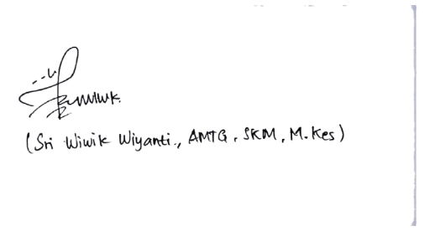

- Sri Wiwik Wiyanti, AMTG, SKM, M.Kes

